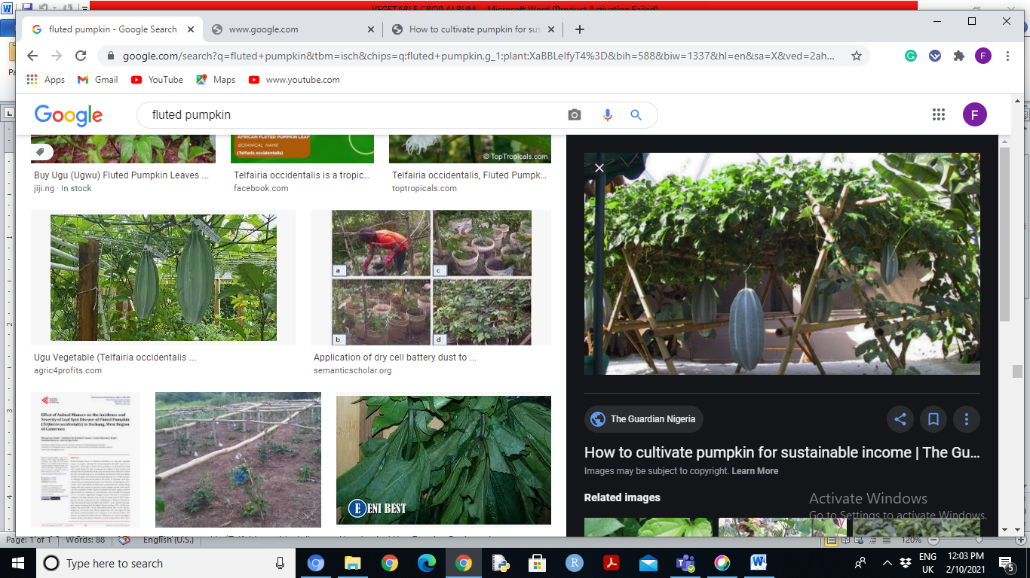 | English Name | Fluted Pumpkin
 | Local Name | Ugu (Igbo), Iroko(Yoruba)
 | Scientific Name | Telfairia occidentalis Hook. F.
 | Origin | Southern Nigeria
 | Distribution | West Africa
 | Edible Portion | Leaf, tender stem and seed
 | Method of Propagation | Seed
 | Number of Days to Maturity | 6 to 8 weeks for leaf,  9 to 10 months for fruit
 | Nutritional Properties | Rich in iron, magnesium, vitamins
 | Medicinal Properties | Remedy for anemia, diabetics and high blood pressure

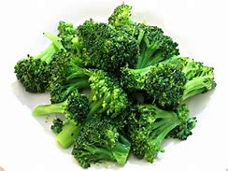 | English Name | Broccoli
 | Local Name | broccoli
 | Scientific Name | Brassica oleracea
 | Origin | Mediterranean region
 | Distribution | Worldwide, cultivated in many countries
 | Edible Portion | Flower buds and leaves
 | Method of Propagation | Seeds, transplants, or cuttings
 | Number of Days to Maturity | 55-65 days
 | Nutritional Properties | Rich in vitamin c and k, good source of fiber, high in antioxidants and cancer-fighting, low in calories and fat
 | Medicinal Properties | May help prevent cancer, supports vimmune function and inflamation

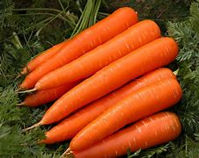 | English Name | CARROTS
 | Local Name | carrots
 | Scientific Name | Daucus carota
 | Origin | Asia and Europe
 | Distribution | Worlwide, cultivated in many countries, including the United states, Europe, Asia, and Australia
 | Edible Portion | roots
 | Method of Propagation | seeds
 | Number of Days to Maturity | 60-70 days
 | Nutritional Properties | Rich in vitamin A, good source of fiber, low in calories and fat, good source of minerals like manganese and copper
 | Medicinal Properties | Supports digestive health and gut bacteria

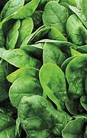 | English Name | SPINACH
 | Local Name | Spinach
 | Scientific Name | Spinacia oleracea
 | Origin | Persia
 | Distribution | Worldwide
 | Edible Portion | leaves
 | Method of Propagation | Seeds, transplants, cuttings
 | Number of Days to Maturity | 20-30 days
 | Nutritional Properties | Rich in iron, good source of protein, low in calories and fat
 | Medicinal Properties | Supports healthy vision and eye health

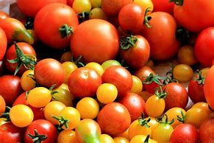 | English Name | TOMATOES
Local name: Tomato (varies by region and language)

Scientific name: Solanum lycopersicum

Origin: Andes Mountains in South America (present-day Peru, Chile, and Ecuador)

Distribution: Worldwide, cultivated in over 180 countries

Edible portion: Fruit (typically red, but also yellow, orange, green, or purple)

Method of propagation: Seeds, grafting, or cuttings

Number of days to maturity: 60-90 days (varies by variety)

Nutritional properties:

- High in vitamins A and C, potassium, and lycopene (an antioxidant)
- Good source of fiber, manganese, and copper
- Low in calories and fat

Medicinal properties:

- Lycopene has been linked to reduced risk of certain cancers and heart disease
- May help lower blood pressure and cholesterol levels
- Antioxidant properties may help protect against cell damage and inflammation

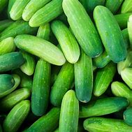 | English Name | CUCUMBER
Local name: Cucumber

Scientific name: Cucumis sativus

Origin: South Asia (India, Sri Lanka)

Distribution: Worldwide, cultivated in many countries, including the United States, Europe, Asia, and Australia

Edible portion: Fruit (cucumber is a type of fruit known as a pepo)

Method of propagation: Seeds, transplants, or cuttings

Number of days to maturity: 50-60 days (from sowing to harvest)

Nutritional properties:

- Water content: 96%
- Low in calories and fat
- Rich in vitamin K, potassium, and antioxidants
- Good source of vitamin C, vitamin A, and fiber
- Supports healthy digestion, hydration, and weight management

Medicinal properties:

- May help reduce blood pressure and cholesterol
- Supports healthy digestion and gut bacteria
- May help reduce inflammation and oxidative stress
- Supports healthy skin, hair, and nails
- May help reduce the risk of cancer, diabetes, and heart disease
- Supports healthy immune function and anti-inflammatory responses

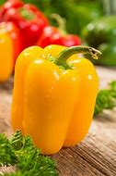 | English Name |  | BELL PEPPERS
Local name: Bell peppers

Scientific name: Capsicum annuum

Origin: Central and South America

Distribution: Worldwide, cultivated in many countries, including the United States, Europe, Asia, and Australia

Edible portion: Fruit (bell peppers are a type of fruit known as a capsule)

Method of propagation: Seeds, transplants, or cuttings

Number of days to maturity: 70-90 days (from sowing to harvest)

Nutritional properties:

- Low in calories and fat
- Rich in vitamin C, vitamin B6, and antioxidants
- Good source of vitamin A, potassium, and fiber
- Supports healthy digestion, immune function, and eye health

Medicinal properties:

- May help reduce inflammation and pain
- Supports healthy cardiovascular function and blood pressure
- May help reduce the risk of cancer, particularly colon, breast, and prostate cancer
- Supports healthy immune function and anti-inflammatory responses
- May help reduce the severity of allergies and asthma
- Supports healthy skin and eye health

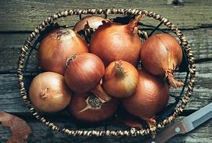 | English Name | ONION
Local name: Onion

Scientific name: Allium cepa

Origin: Central Asia (Iran, Pakistan)

Distribution: Worldwide, cultivated in many countries, including the United States, Europe, Asia, and Australia

Edible portion: Bulb (the underground storage organ)

Method of propagation: Seeds, transplants, or sets (small bulbs)

Number of days to maturity: 120-150 days (from sowing to harvest)

Nutritional properties:

- Low in calories and fat
- Rich in fiber, vitamin C, and potassium
- Good source of vitamin K, folate, and antioxidants
- Supports healthy digestion, immune function, and heart health

Medicinal properties:

- May help reduce inflammation and cholesterol
- Supports healthy blood sugar levels and insulin function
- May help reduce the risk of cancer, particularly colorectal, prostate, and breast cancer
- Supports healthy immune function and anti-inflammatory responses
- May help reduce the severity of respiratory issues like asthma and bronchitis
- Supports healthy skin and wound healing

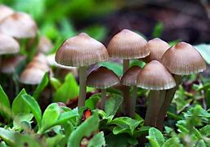 | English Name | MUSHROOM
Local name: Mushroom

Scientific name: Various species (e.g., Agaricus bisporus, Pleurotus ostreatus, Shiitake lentinula edodes)

Origin: Worldwide, depending on species

Distribution: Worldwide, cultivated and wild-harvested in many countries

Edible portion: Fruiting body (cap and stem)

Method of propagation: Spores, spawn (vegetative material), or cuttings

Number of days to maturity: Varies by species, typically 1-6 months

Nutritional properties:

- Low in calories and fat
- Rich in protein, fiber, and antioxidants
- Good source of vitamin D, copper, and selenium
- Supports healthy immune function, digestion, and cardiovascular health

Medicinal properties:

- May help boost immune system and reduce inflammation
- Supports healthy cardiovascular function and blood pressure
- May help reduce the risk of cancer, particularly breast, prostate, and colon cancer
- Supports healthy gut bacteria and digestive health
- May help reduce the severity of respiratory issues like bronchitis and asthma
- Supports healthy skin and wound healing

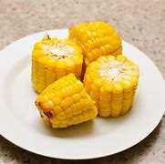 | English Name | CORN
Local name: Corn

Scientific name: Zea mays

Origin: Central America (Mexico, Guatemala)

Distribution: Worldwide, cultivated in many countries, including the United States, Europe, Asia, and Africa

Edible portion: Kernel (seed), cob, and leaves (in some cultures)

Method of propagation: Seeds

Number of days to maturity: 60-120 days (from sowing to harvest)

Nutritional properties:

- Rich in carbohydrates, fiber, and protein
- Good source of vitamin C, thiamin, and folate
- Supports healthy digestion, energy production, and immune function
- Gluten-free, making it a popular choice for people with gluten intolerance

Medicinal properties:

- May help reduce blood pressure and cholesterol
- Supports healthy cardiovascular function and blood sugar control
- May help reduce the risk of cancer, particularly colon and breast cancer
- Supports healthy gut bacteria and digestive health
- May help reduce the severity of diarrhea and other gastrointestinal issues
- Supports healthy skin and eye health

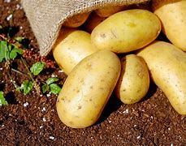 | English Name | POTATOES
Local name: Potato

Scientific name: Solanum tuberosum

Origin: Andean region of South America (Peru, Bolivia)

Distribution: Worldwide, cultivated in many countries, including the United States, Europe, Asia, and Africa

Edible portion: Tuber (underground stem)

Method of propagation: Tubers, seeds, or cuttings

Number of days to maturity: 70-100 days (from planting to harvest)

Nutritional properties:

- Rich in complex carbohydrates, fiber, and potassium
- Good source of vitamin C, vitamin B6, and manganese
- Supports healthy digestion, energy production, and immune function
- Gluten-free, making it a popular choice for people with gluten intolerance

Medicinal properties:

- May help reduce blood pressure and cholesterol
- Supports healthy cardiovascular function and blood sugar control
- May help reduce the risk of cancer, particularly colon and breast cancer
- Supports healthy gut bacteria and digestive health
- May help reduce the severity of diarrhea and other gastrointestinal issues
- Supports healthy skin and eye health

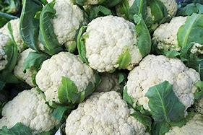 | English Name | CAULIFLOWER
Local name: Cauliflower

Scientific name: Brassica oleracea var. botrytis

Origin: Mediterranean region (Italy, Greece)

Distribution: Worldwide, cultivated in many countries, including the United States, Europe, Asia, and Australia

Edible portion: Head (inflorescence)

Method of propagation: Seeds, transplants, or cuttings

Number of days to maturity: 55-65 days (from sowing to harvest)

Nutritional properties:

- Rich in vitamins C and K
- Good source of fiber, vitamin B6, and potassium
- Low in calories and fat
- Supports healthy digestion, immune function, and cardiovascular health

Medicinal properties:

- May help reduce inflammation and cancer risk
- Supports healthy detoxification and antioxidant defenses
- May help reduce the severity of respiratory issues like asthma and bronchitis
- Supports healthy gut bacteria and digestive health
- May help reduce the risk of neurodegenerative diseases like Alzheimer's and Parkinson's
- Supports healthy skin and eye health

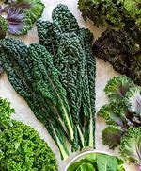 | English Name | KALE
Local name: Kale

Scientific name: Brassica oleracea var. acephala

Origin: Europe (Mediterranean region)

Distribution: Worldwide, cultivated in many countries, including the United States, Europe, Asia, and Australia

Edible portion: Leaves

Method of propagation: Seeds, transplants, or cuttings

Number of days to maturity: 50-60 days (from sowing to harvest)

Nutritional properties:

- Rich in vitamins A, C, and K
- Good source of fiber, calcium, and iron
- Low in calories and fat
- Supports healthy digestion, immune function, and cardiovascular health

Medicinal properties:

- May help reduce inflammation and cancer risk
- Supports healthy detoxification and antioxidant defenses
- May help reduce the severity of respiratory issues like asthma and bronchitis
- Supports healthy gut bacteria and digestive health
- May help reduce the risk of neurodegenerative diseases like Alzheimer's and Parkinson's
- Supports healthy skin and eye health

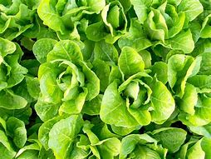 | English Name | LETTUCE
Local name: Lettuce

Scientific name: Lactuca sativa

Origin: Mediterranean region (Egypt, Greece)

Distribution: Worldwide, cultivated in many countries, including the United States, Europe, Asia, and Australia

Edible portion: Leaves

Method of propagation: Seeds, transplants, or cuttings

Number of days to maturity: 40-70 days (from sowing to harvest)

Nutritional properties:

- Low in calories and fat
- Rich in vitamins A and K
- Good source of fiber, vitamin C, and potassium
- Supports healthy digestion, immune function, and cardiovascular health

Medicinal properties:

- May help reduce inflammation and cancer risk
- Supports healthy detoxification and antioxidant defenses
- May help reduce the severity of respiratory issues like asthma and bronchitis
- Supports healthy gut bacteria and digestive health
- May help reduce the risk of neurodegenerative diseases like Alzheimer's and Parkinson's
- Supports healthy skin and eye health

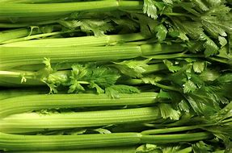 | English Name | CELERY
Local name: Celery

Scientific name: Apium graveolens

Origin: Mediterranean region (Italy, France)

Distribution: Worldwide, cultivated in many countries, including the United States, Europe, Asia, and Australia

Edible portion: Stalks and leaves

Method of propagation: Seeds, transplants, or cuttings

Number of days to maturity: 60-90 days (from sowing to harvest)

Nutritional properties:

- Low in calories and fat
- Rich in vitamins A, C, and K
- Good source of fiber, potassium, and antioxidants
- Supports healthy digestion, immune function, and cardiovascular health

Medicinal properties:

- May help reduce inflammation and cancer risk
- Supports healthy detoxification and antioxidant defenses
- May help reduce the severity of respiratory issues like asthma and bronchitis
- Supports healthy gut bacteria and digestive health
- May help reduce blood pressure and cholesterol levels
- Supports healthy skin and eye health
- May help reduce anxiety and stress due to its sedative properties

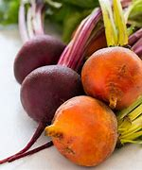 | English Name | BEETS
Local name: Beets

Scientific name: Beta vulgaris

Origin: Mediterranean region (Italy, Greece)

Distribution: Worldwide, cultivated in many countries, including the United States, Europe, Asia, and Australia

Edible portion: Roots (beetroot) and leaves (beet greens)

Method of propagation: Seeds, transplants, or cuttings

Number of days to maturity: 60-90 days (from sowing to harvest)

Nutritional properties:

- Rich in vitamins A, C, and K
- Good source of fiber, potassium, and antioxidants
- Supports healthy digestion, immune function, and cardiovascular health
- Low in calories and fat
- High in nitrates, which can help lower blood pressure

Medicinal properties:

- May help reduce inflammation and cancer risk
- Supports healthy detoxification and antioxidant defenses
- May help reduce the severity of respiratory issues like asthma and bronchitis
- Supports healthy gut bacteria and digestive health
- May help reduce blood pressure and cholesterol levels
- Supports healthy skin and eye health
- May help reduce the risk of anemia due to its high iron content
- May help improve exercise performance and endurance due to its high nitrate content

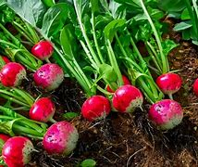 | English Name | RADISH
Local name: Radish

Scientific name: Raphanus sativus

Origin: Asia (China, India)

Distribution: Worldwide, cultivated in many countries, including the United States, Europe, Asia, and Australia

Edible portion: Roots

Method of propagation: Seeds, transplants, or cuttings

Number of days to maturity: 20-30 days (from sowing to harvest)

Nutritional properties:

- Low in calories and fat
- Rich in vitamins C and K
- Good source of fiber, potassium, and antioxidants
- Supports healthy digestion, immune function, and cardiovascular health

Medicinal properties:

- May help reduce inflammation and cancer risk
- Supports healthy detoxification and antioxidant defenses
- May help reduce the severity of respiratory issues like asthma and bronchitis
- Supports healthy gut bacteria and digestive health
- May help reduce blood pressure and cholesterol levels
- Supports healthy skin and eye health
- May help reduce the risk of anemia due to its high iron content
- May help support liver and kidney health

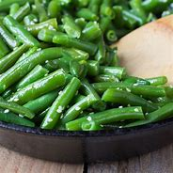 | English Name | GREEN BEANS
Local name: Green beans

Scientific name: Phaseolus vulgaris

Origin: Central and South America (Mexico, Peru)

Distribution: Worldwide, cultivated in many countries, including the United States, Europe, Asia, and Africa

Edible portion: Pods

Method of propagation: Seeds, transplants, or cuttings

Number of days to maturity: 50-60 days (from sowing to harvest)

Nutritional properties:

- Low in calories and fat
- Rich in vitamins C and K
- Good source of fiber, potassium, and antioxidants
- Supports healthy digestion, immune function, and cardiovascular health
- High in folate, which supports healthy cell growth and development

Medicinal properties:

- May help reduce inflammation and cancer risk
- Supports healthy detoxification and antioxidant defenses
- May help reduce the severity of respiratory issues like asthma and bronchitis
- Supports healthy gut bacteria and digestive health
- May help reduce blood pressure and cholesterol levels
- Supports healthy skin and eye health
- May help reduce the risk of anemia due to its high iron content
- May help support healthy bones and muscles

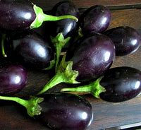 | English Name | EGG PLANT
Local name: Eggplant

Scientific name: Solanum melongena

Origin: Asia (India, China)

Distribution: Worldwide, cultivated in many countries, including the United States, Europe, Asia, and Africa

Edible portion: Fruits (eggplant is a type of berry)

Method of propagation: Seeds, transplants, or cuttings

Number of days to maturity: 60-90 days (from sowing to harvest)

Nutritional properties:

- Low in calories and fat
- Rich in vitamins C and K
- Good source of fiber, potassium, and antioxidants
- Supports healthy digestion, immune function, and cardiovascular health
- High in nasunin, an antioxidant that supports healthy brain function and memory

Medicinal properties:

- May help reduce inflammation and cancer risk
- Supports healthy detoxification and antioxidant defenses
- May help reduce the severity of respiratory issues like asthma and bronchitis
- Supports healthy gut bacteria and digestive health
- May help reduce blood pressure and cholesterol levels
- Supports healthy skin and eye health
- May help reduce the risk of anemia due to its high iron content
- May help support healthy bones and muscles

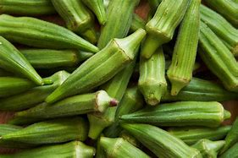 | English Name | OKRA
Local name: Okra

Scientific name: Abelmoschus esculentus

Origin: West Africa (Gambia, Senegal, and Guinea)

Distribution: Widely cultivated in tropical and subtropical regions, including Africa, Asia, and the Americas

Edible portion: Pods

Method of propagation: Seeds, transplants, or cuttings

Number of days to maturity: 50-60 days (from sowing to harvest)

Nutritional properties:

- Rich in vitamins A and C
- Good source of fiber, potassium, and antioxidants
- Supports healthy digestion, immune function, and cardiovascular health
- High in folate, which supports healthy cell growth and development
- Low in calories and fat

Medicinal properties:

- May help reduce inflammation and cancer risk
- Supports healthy detoxification and antioxidant defenses
- May help reduce the severity of respiratory issues like asthma and bronchitis
- Supports healthy gut bacteria and digestive health
- May help reduce blood pressure and cholesterol levels
- Supports healthy skin and eye health
- May help reduce the risk of anemia due to its high iron content
- May help support healthy bones and muscles

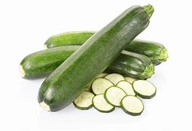 | English Name | ZUCCHINI
Local name: Zucchini

Scientific name: Cucurbita pepo

Origin: Central and South America (Mexico, Peru)

Distribution: Worldwide, cultivated in many countries, including the United States, Europe, Asia, and Africa

Edible portion: Fruits (zucchini is a type of summer squash)

Method of propagation: Seeds, transplants, or cuttings

Number of days to maturity: 35-45 days (from sowing to harvest)

Nutritional properties:

- Low in calories and fat
- Rich in vitamins C and K
- Good source of fiber, potassium, and antioxidants
- Supports healthy digestion, immune function, and cardiovascular health
- High in water content, making it a refreshing and hydrating food

Medicinal properties:

- May help reduce inflammation and cancer risk
- Supports healthy detoxification and antioxidant defenses
- May help reduce the severity of respiratory issues like asthma and bronchitis
- Supports healthy gut bacteria and digestive health
- May help reduce blood pressure and cholesterol levels
- Supports healthy skin and eye health
- May help reduce the risk of anemia due to its high iron content
- May help support healthy bones and muscles

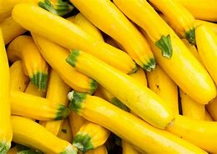 | English Name | YELLOW SQUASH
Local name: Yellow squash

Scientific name: Cucurbita pepo

Origin: North America (Mexico, United States)

Distribution: Worldwide, cultivated in many countries, including the United States, Europe, Asia, and Africa

Edible portion: Fruit (yellow squash is a type of summer squash)

Method of propagation: Seeds, transplants, or cuttings

Number of days to maturity: 35-45 days (from sowing to harvest)

Nutritional properties:

- Rich in vitamins A and C
- Good source of fiber, potassium, and antioxidants
- Supports healthy digestion, immune function, and cardiovascular health
- Low in calories and fat
- Good source of minerals like magnesium and manganese

Medicinal properties:

- May help reduce inflammation and cancer risk
- Supports healthy detoxification and antioxidant defenses
- May help reduce the severity of respiratory issues like asthma and bronchitis
- Supports healthy gut bacteria and digestive health
- May help reduce blood pressure and cholesterol levels
- Supports healthy skin and eye health

 | English Name | ACORN SQUASH
Local name: Acorn squash

Scientific name: Cucurbita pepo

Origin: North America (Mexico, United States)

Distribution: Worldwide, cultivated in many countries, including the United States, Europe, Asia, and Africa

Edible portion: Fruits (acorn squash is a type of winter squash)

Method of propagation: Seeds, transplants, or cuttings

Number of days to maturity: 100-120 days (from sowing to harvest)

Nutritional properties:

- Rich in vitamins A and C
- Good source of fiber, potassium, and antioxidants
- Supports healthy digestion, immune function, and cardiovascular health
- High in beta-carotene, which supports healthy vision and skin
- Low in calories and fat

Medicinal properties:

- May help reduce inflammation and cancer risk
- Supports healthy detoxification and antioxidant defenses
- May help reduce the severity of respiratory issues like asthma and bronchitis
- Supports healthy gut bacteria and digestive health
- May help reduce blood pressure and cholesterol levels
- Supports healthy skin and eye health
- May help reduce the risk of anemia due to its high iron content
- May help support healthy bones and muscles

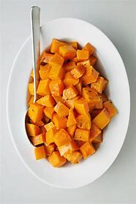 | English Name | BUTTERNUT SQUASH
Local name: Butternut squash

Scientific name: Cucurbita moschata

Origin: North America (Mexico, United States)

Distribution: Worldwide, cultivated in many countries, including the United States, Europe, Asia, and Africa

Edible portion: Fruits (butternut squash is a type of winter squash)

Method of propagation: Seeds, transplants, or cuttings

Number of days to maturity: 110-120 days (from sowing to harvest)

Nutritional properties:

- Rich in vitamins A and C
- Good source of fiber, potassium, and antioxidants
- Supports healthy digestion, immune function, and cardiovascular health
- High in beta-carotene, which supports healthy vision and skin
- Low in calories and fat
- Good source of minerals like magnesium and manganese

Medicinal properties:

- May help reduce inflammation and cancer risk
- Supports healthy detoxification and antioxidant defenses
- May help reduce the severity of respiratory issues like asthma and bronchitis
- Supports healthy gut bacteria and digestive health
- May help reduce blood pressure and cholesterol levels
- Supports healthy skin and eye health
- May help reduce the risk of anemia due to its high iron content
- May help support healthy bones and muscles

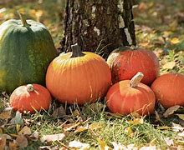 | English Name | PUMPKIN
Local name: Pumpkin

Scientific name: Cucurbita pepo

Origin: North America (Mexico, United States)

Distribution: Worldwide, cultivated in many countries, including the United States, Europe, Asia, and Africa

Edible portion: Fruits (pumpkin is a type of winter squash)

Method of propagation: Seeds, transplants, or cuttings

Number of days to maturity: 100-120 days (from sowing to harvest)

Nutritional properties:

- Rich in vitamins A and C
- Good source of fiber, potassium, and antioxidants
- Supports healthy digestion, immune function, and cardiovascular health
- High in beta-carotene, which supports healthy vision and skin
- Low in calories and fat
- Good source of minerals like magnesium and manganese

Medicinal properties:

- May help reduce inflammation and cancer risk
- Supports healthy detoxification and antioxidant defenses
- May help reduce the severity of respiratory issues like asthma and bronchitis
- Supports healthy gut bacteria and digestive health
- May help reduce blood pressure and cholesterol levels
- Supports healthy skin and eye health
- May help reduce the risk of anemia due to its high iron content
- May help support healthy bones and muscles

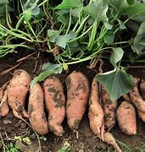 | English Name | SWEET POTATO
Local name: Sweet potato

Scientific name: Ipomoea batatas

Origin: Central and South America (Peru, Ecuador)

Distribution: Worldwide, cultivated in many countries, including the United States, Africa, Asia, and Latin America

Edible portion: Tubers (roots)

Method of propagation: Tubers, cuttings, or slips (stem cuttings)

Number of days to maturity: 90-120 days (from planting to harvest)

Nutritional properties:

- Rich in vitamins A and C
- Good source of fiber, potassium, and antioxidants
- Supports healthy digestion, immune function, and cardiovascular health
- High in beta-carotene, which supports healthy vision and skin
- Low in calories and fat
- Good source of minerals like iron, magnesium, and manganese

Medicinal properties:

- May help reduce inflammation and cancer risk
- Supports healthy detoxification and antioxidant defenses
- May help reduce the severity of respiratory issues like asthma and bronchitis
- Supports healthy gut bacteria and digestive health
- May help reduce blood pressure and cholesterol levels
- Supports healthy skin and eye health
- May help reduce the risk of anemia due to its high iron content
- May help support healthy bones and muscles

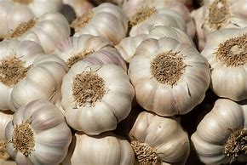 | English Name | GARLIC
Local name: Garlic

Scientific name: Allium sativum

Origin: Central Asia (Kazakhstan, Uzbekistan)

Distribution: Worldwide, cultivated in many countries, including the United States, Europe, Asia, and Africa

Edible portion: Bulbs (cloves)

Method of propagation: Cloves, seeds, or divisions

Number of days to maturity: 90-120 days (from planting to harvest)

Nutritional properties:

- Rich in vitamins C and B6
- Good source of minerals like potassium, calcium, and iron
- Supports healthy digestion, immune function, and cardiovascular health
- Has antibacterial, antiviral, and antifungal properties
- Low in calories and fat

Medicinal properties:

- May help reduce cholesterol and blood pressure
- Has natural antibacterial and antiseptic properties
- May help reduce the severity of respiratory issues like asthma and bronchitis
- Supports healthy gut bacteria and digestive health
- May help reduce the risk of certain cancers
- Has natural anti-inflammatory properties

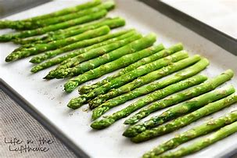 | English Name | ASPARAGUS
- Local name: Asparagus
- Scientific name: Asparagus officinalis
- Origin: Eurasia
- Distribution: Worldwide
- Edible portion: Young shoots
- Method of propagation: Seeds, transplants, or cuttings
- Number of days to maturity: 2-12 weeks
- Nutritional properties: Rich in vitamins B, C, E, and K, calcium, magnesium, zinc, dietary fiber, protein, beta-carotene, thiamin, riboflavin, rutin, niacin, iron, phosphorus, potassium, copper, manganese, selenium, and chromium
- Medicinal properties: Can help fight diabetes, cancer, heart disease, arthritis, high blood pressure, and stroke; can help improve eye health, skin health, and prostate health

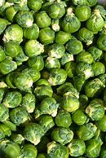 | English Name | BRUSSELS SPROUTS
- Local name: Brussels sprouts
- Scientific name: Brassica oleracea var. gemmifera
- Origin: Mediterranean region
- Distribution: Worldwide
- Edible portion: Buds (small, green, and tightly closed)
- Method of propagation: Seeds, transplants, or cuttings
- Number of days to maturity: 80-120 days
- Nutritional properties: Rich in vitamins C and K, folate, fiber, potassium, and antioxidants; good source of vitamins B6 and B1, and minerals like manganese and iron
- Medicinal properties: May help reduce cancer risk, support cardiovascular health, and aid in detoxification; may also help manage blood sugar levels and support healthy digestion

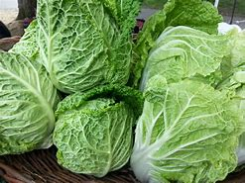 | English Name | CABBAGE
- Local name: Cabbage
- Scientific name: Brassica oleracea var. capitata
- Origin: Mediterranean region
- Distribution: Worldwide
- Edible portion: Leaves (compact, dense, and tightly wrapped)
- Method of propagation: Seeds, transplants, or cuttings
- Number of days to maturity: 70-100 days
- Nutritional properties: Rich in vitamins C and K, fiber, potassium, and antioxidants; good source of vitamins B6 and B1, and minerals like manganese and iron
- Medicinal properties: May help reduce cancer risk, support cardiovascular health, and aid in detoxification; may also help manage blood sugar levels, support healthy digestion, and reduce inflammation

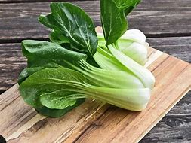 | English Name | BOK CHOY
- Local name: Bok choy
- Scientific name: Brassica rapa var. chinensis
- Origin: China
- Distribution: Worldwide, commonly cultivated in Asia and the United States
- Edible portion: Leaves and stalks
- Method of propagation: Seeds, transplants, or cuttings
- Number of days to maturity: 40-50 days
- Nutritional properties: Rich in vitamins A, C, and K, calcium, iron, potassium, and fiber; low in calories
- Medicinal properties: May help reduce cancer risk, support cardiovascular health, and aid in detoxification; may also help manage blood sugar levels, support healthy digestion, and reduce inflammation

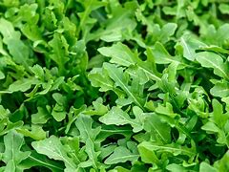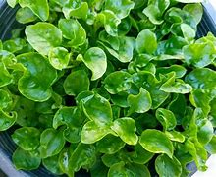 | English Name | WATERCRESS
- Local name: Watercress
- Scientific name: Nasturtium officinale
- Origin: Europe and Asia
- Distribution: Worldwide, commonly found in streams and rivers
- Edible portion: Leaves and stems
- Method of propagation: Seeds, transplants, or cuttings
- Number of days to maturity: 50-60 days
- Nutritional properties: Rich in vitamins A, C, and K, calcium, iron, potassium, and fiber; low in calories
- Medicinal properties: May help reduce cancer risk, support cardiovascular health, and aid in detoxification; may also help manage blood sugar levels, support healthy digestion, and reduce inflammation

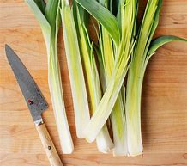 | English Name | LEEKS
- Local name: Leeks
- Scientific name: Allium ampeloprasum
- Origin: Mediterranean region
- Distribution: Worldwide, commonly cultivated in Europe, North America, and Asia
- Edible portion: Leaves and stems
- Method of propagation: Seeds, transplants, or divisions
- Number of days to maturity: 120-150 days
- Nutritional properties: Rich in vitamins K and C, potassium, fiber, and antioxidants; low in calories
- Medicinal properties: May help reduce cancer risk, support cardiovascular health, and aid in detoxification; may also help manage blood sugar levels, support healthy digestion, and reduce inflammation

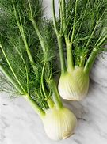 | English Name | FENNEL
Local name: Fennel
Scientific name: Foeniculum vulgare
Origin: Mediterranean region
Distribution: Worldwide, commonly cultivated in Europe, North America, and Asia
Edible portion: Leaves, stems, and seeds
Method of propagation: Seeds, transplants, or divisions
Number of days to maturity: 60-90 days
Nutritional properties:

- Rich in vitamins C and K, potassium, and fiber
- Good source of manganese, copper, and iron
- Low in calories

Medicinal properties:

- May help reduce digestive issues, such as bloating and gas
- Support immune function and reduce inflammation
- Act as a natural antispasmodic and relieve menstrual cramps
- Support respiratory health and relieve symptoms of bronchitis and asthma
- May help reduce cancer risk and support cardiovascular health

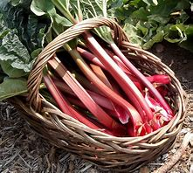 | English Name | RHUBARB
Local name: Rhubarb
Scientific name: Rheum rhabarbarum
Origin: Asia, specifically China and Tibet
Distribution: Worldwide, commonly cultivated in Europe, North America, and Asia
Edible portion: Stalks (petioles)
Method of propagation: Divisions, transplants, or seed
Number of days to maturity: 60-90 days
Nutritional properties:

- Rich in vitamins C and K, potassium, and fiber
- Good source of manganese, copper, and iron
- Low in calories

Medicinal properties:

- Has been used to treat digestive issues, such as constipation and diarrhea
- May help reduce inflammation and act as an antispasmodic
- Has been used to treat respiratory issues, such as bronchitis and asthma
- May help reduce cancer risk and support cardiovascular health
- Has been used to treat skin conditions, such as acne and eczema

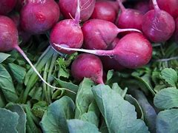 | English Name | TURNIPS
Local name: Turnips
Scientific name: Brassica rapa
Origin: Europe and Asia
Distribution: Worldwide, commonly cultivated in Europe, North America, and Asia
Edible portion: Roots and leaves
Method of propagation: Seeds, transplants, or direct sowing
Number of days to maturity: 40-60 days (roots), 20-30 days (leaves)
Nutritional properties:

- Rich in vitamins C and K, potassium, and fiber
- Good source of manganese, copper, and iron
- Low in calories

Medicinal properties:

- May help reduce cancer risk and support cardiovascular health
- Support immune function and reduce inflammation
- May help manage blood sugar levels and support healthy digestion
- Act as a natural antiseptic and antibacterial agent
- Support respiratory health and relieve symptoms of bronchitis and asthma

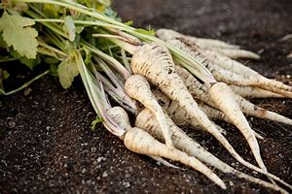 | English Name | PARSNIPS
Local name: Parsnips
Scientific name: Pastinaca sativa
Origin: Europe and Asia
Distribution: Worldwide, commonly cultivated in Europe, North America, and Asia
Edible portion: Roots
Method of propagation: Seeds, transplants, or direct sowing
Number of days to maturity: 100-120 days
Nutritional properties:

- Rich in vitamins C and K, potassium, and fiber
- Good source of manganese, copper, and iron
- Low in calories
- High in antioxidants and anti-inflammatory compounds

Medicinal properties:

- May help reduce cancer risk and support cardiovascular health
- Support immune function and reduce inflammation
- May help manage blood sugar levels and support healthy digestion
- Act as a natural antiseptic and antibacterial agent
- Support respiratory health and relieve symptoms of bronchitis and asthma

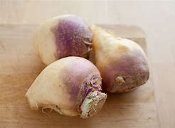 | English Name | RUTABAGA
Local name: Rutabaga
Scientific name: Brassica napus
Origin: Scandinavia, Finland or Russia
Distribution: Worldwide, commonly cultivated in Europe, North America and Asia
Edible portion: Roots and leaves
Method of propagation: Seeds, transplants or direct sowing
Number of days to maturity: 100-120 days
Nutritional properties:
- Rich in vitamins C and fiber
- Good source of manganese, copper and iron
- Low in calories
Medicinal properties:
- May help reduce cancer risk and support cardiovascular health
- Support immune function and reduce inflammation
- May help manage blood sugar levels and support healthy digestion
- Act as a natural antiseptic and antibacterial agent
- Support respiratory health and relieve symptoms of bronchitis and asthma

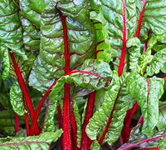 | English Name | SWISS CHARD
Local name: Swiss chard
Scientific name: Beta vulgaris subspecies Beta vulgaris, Cicla Group and Flavescens Group
Origin: Identified by a Swiss botanist
Distribution: Worldwide
Edible portion: Leaves and stems
Method of propagation: Seeds
Number of days to maturity: 84 days
Nutritional properties: Rich in vitamins A, K and C, magnesium, manganese, iron and potassium
Medicinal properties: Can help reduce cancer risk and support cardiovascular health, immune function and healthy digestion

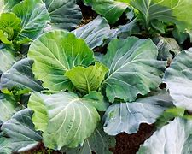 | English Name  Local name: Collard greens  Scientific name: Brassica oleracea acephala  Origin: Mediterranean region  Distribution: Worldwide, commonly cultivated in Southern United States, Africa, and Asia  Edible portion: Leaves  Method of propagation: Seeds, transplants, or direct sowing  Number of days to maturity: 50-60 days  Nutritional properties:  - Rich in vitamins A, C, and K  - High in fiber, calcium, and iron  - Good source of potassium, manganese, and copper  Medicinal properties:  - May help reduce cancer risk and support cardiovascular health  - Support immune function and reduce inflammation  - May help manage blood sugar levels and support healthy digestion  - Act as a natural antiseptic and antibacterial agent  - Support eye health and reduce the risk of age-related macular degeneration | COLLARD GREENS

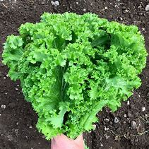 | English Name | MUSTARD GREENS
Local name: Mustard greens
Scientific name: Brassica juncea
Origin: Himalayan region of India
Distribution: Worldwide, commonly cultivated in Asia, Africa, and the Southern United States
Edible portion: Leaves and stems
Method of propagation: Seeds, transplants, or direct sowing
Number of days to maturity: 40-50 days
Nutritional properties:
- Rich in vitamins A, C, and K
- High in fiber, calcium, and iron
- Good source of potassium, manganese, and copper
- Contain antioxidants and anti-inflammatory compounds
Medicinal properties:
- May help reduce cancer risk and support cardiovascular health
- Support immune function and reduce inflammation
- May help manage blood sugar levels and support healthy digestion
- Act as a natural antiseptic and antibacterial agent
- Support eye health and reduce the risk of age-related macular degeneration

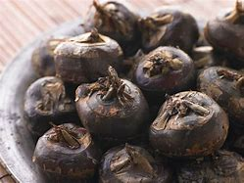 | English Name | WATER CHESTNUTS
Local name: Water chestnuts
Scientific name: Eleocharis dulcis
Origin: Asia, specifically China and India
Distribution: Worldwide, commonly cultivated in Asia, Africa, and the Pacific Islands
Edible portion: Corms (underwater stems)
Method of propagation: Seeds, transplants, or division
Number of days to maturity: 120-150 days
Nutritional properties:
- Low in calories and fat
- Rich in carbohydrates, fiber, and protein
- Good source of potassium, magnesium, and manganese
- Contain antioxidants and anti-inflammatory compounds
Medicinal properties:
- May help reduce cancer risk and support cardiovascular health
- Support immune function and reduce inflammation
- May help manage blood sugar levels and support healthy digestion
- Act as a natural antiseptic and antibacterial agent
- Support respiratory health and relieve symptoms of bronchitis and asthma

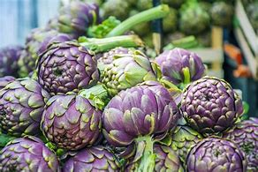 | English Name | ARTICHOKES
Local name: Artichokes
Scientific name: Globe artichokes
Origin: Italy
Distribution: Worldwide
Edible portion: Leaves, stem, heart
Method of propagation: Seeds, transplants, or division
Number of days to maturity: 35-45 days
Nutritional properties:
- Rich in vitamins A, C, and K
- High in fiber, calcium, and iron
- Good source of potassium, manganese, and copper
- Contain antioxidants and anti-inflammatory compounds
Medicinal properties:
- May help reduce cancer risk and support cardiovascular health
- Support immune function and reduce inflammation
- May help manage blood sugar levels and support healthy digestion
- Act as a natural antiseptic and antibacterial agent
- Support eye health and reduce the risk of age-related macular degeneration

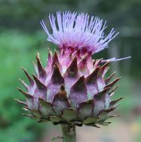 | English Name | CARDOON
Local name: Cardoon
Scientific name: Cynara cardunculus
Origin: Mediterranean region
Distribution: Worldwide
Edible portion: Stalks
Method of propagation: Seeds
Number of days to maturity: 100
Nutritional properties:
- High in fiber, calcium, potassium, iron, magnesium, manganese, sodium, and zinc
- Rich in vitamins B1, B2, B3, B5, B6, B9, and C
Medicinal properties:
- May help reduce cancer risk and support cardiovascular health
- Support immune function and reduce inflammation
- May help manage blood sugar levels and support healthy digestion
- Act as a natural antiseptic and antibacterial agent
- Support eye health and reduce the risk of age-related macular degeneration

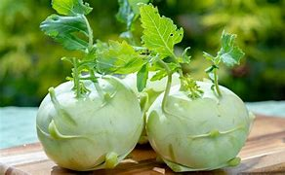 | English Name | KOHLRABI
Local name: Kohlrabi
Scientific name: Brassica oleracea var. gongylodes
Origin: Europe, specifically Germany and Austria
Distribution: Worldwide
Edible portion: Stem and leaves
Method of propagation: Seeds
Number of days to maturity: 50-60
Nutritional properties:
- High in vitamins C and K
- Good source of potassium, fiber, and antioxidants
- Low in calories and fat
Medicinal properties:
- May help reduce cancer risk and support cardiovascular health
- Support immune function and reduce inflammation
- May help manage blood sugar levels and support healthy digestion
- Act as a natural antiseptic and antibacterial agent
- Support eye health and reduce the risk of age-related macular degeneration

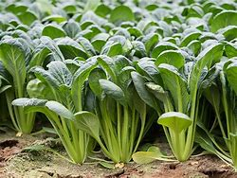 | English Name | KOMATSUNA
Local name: Komatsuna
Scientific name: Brassica rapa var. perviridis
Origin: Japan
Distribution: Worldwide
Edible portion: Leaves and stems
Method of propagation: Seeds
Number of days to maturity: 40
Nutritional properties: Abundant in beta carotene, vitamin C, calcium and iron
Medicinal properties: May help prevent cancer and diabetes, rejuvenate skin and strengthen bones

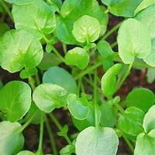 | English Name | LAND CRESS
Local name: Land Cress
Scientific name: Barbarea verna
Origin: Europe and Western Asia
Distribution: Worldwide, naturalized in many regions
Edible portion: Leaves and stems
Method of propagation: Seeds
Number of days to maturity: 50-60
Nutritional properties:
- Rich in vitamins A, C, and K
- Good source of calcium, iron, and potassium
- High in antioxidants and anti-inflammatory compounds
Medicinal properties:
- May help reduce cancer risk and support cardiovascular health
- Support immune function and reduce inflammation
- May help manage blood sugar levels and support healthy digestion
- Act as a natural antiseptic and antibacterial agent
- Support eye health and reduce the risk of age-related macular degeneration

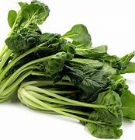 | English Name | TATSOI
Local name: Tatsoi
Scientific name: Brassica napa var. rosularis
Origin: China
Distribution: Worldwide, commonly cultivated in Asia and the United States
Edible portion: Leaves and stems
Method of propagation: Seeds
Number of days to maturity: 40-50
Nutritional properties:
- Rich in vitamins A, C, and K
- Good source of calcium, iron, and potassium
- High in antioxidants and anti-inflammatory compounds
Medicinal properties:
- May help reduce cancer risk and support cardiovascular health
- Support immune function and reduce inflammation
- May help manage blood sugar levels and support healthy digestion
- Act as a natural antiseptic and antibacterial agent
- Support eye health and reduce the risk of age-related macular degeneration

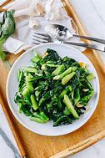 | English Name | CHINESE BROCCOLI
Local name: Chinese Broccoli
Scientific name: Brassica oleracea var. alboglabra
Origin: China
Distribution: Worldwide, commonly cultivated in Asia and the United States
Edible portion: Flower buds, stems, and leaves
Method of propagation: Seeds
Number of days to maturity: 50-60
Nutritional properties:
- Rich in vitamins C and K
- Good source of fiber, calcium, and iron
- High in antioxidants and anti-inflammatory compounds
Medicinal properties:
- May help reduce cancer risk and support cardiovascular health
- Support immune function and reduce inflammation
- May help manage blood sugar levels and support healthy digestion
- Act as a natural antiseptic and antibacterial agent
- Support eye health and reduce the risk of age-related macular degeneration

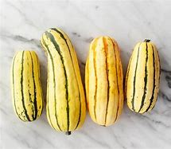 | English Name | DELICATE SQUASH
Local name: Delicate Squash (also known as Pattypan Squash or Sunburst Squash)
Scientific name: Cucurbita pepo
Origin: North America
Distribution: Worldwide, commonly cultivated in warm temperate regions
Edible portion: Fruit (squash)
Method of propagation: Seeds
Number of days to maturity: 35-45
Nutritional properties:
- Low in calories and fat
- Rich in vitamins A and C, potassium, and fiber
- Good source of antioxidants and anti-inflammatory compounds
Medicinal properties:
- May help reduce cancer risk and support cardiovascular health
- Support immune function and reduce inflammation
- May help manage blood sugar levels and support healthy digestion
- Act as a natural antiseptic and antibacterial agent
- Support eye health and reduce the risk of age-related macular degeneration

English Name
Local Name
Scientific Name
Origin
Distribution
Edible Portion
Method of Propagation
Number of Days to Maturity
Nutritional Properties
Medicinal Properties

English Name
Local Name
Scientific Name
Origin
Distribution
Edible Portion
Method of Propagation
Number of Days to Maturity
Nutritional Properties
Medicinal Properties

